**DWS Product Guide**

Catalog

**1.Introduction : 1**

**2.Chapter 1 : 2**

**2.1 Selecting the Right Equipment : 2**

**2.2 Main Components of a DWS : 3**

**2.3 What Does a DWS Provide : 4**

**2.4 What kind of Items do DWS systems typically handle? : 4**

**3.Chapter 2 : 5**

**3.1 Automation in DWS using IT Software : 5**

**3.1.1 User Interface(Web application) : 5**

**3.1.2 Weighing and VMS Integration : 12**

**3.1.3 Camera Integration Software : 12**

**3.1.4 Data Management : 13**

**1.Introduction :**

Dimensioning, Weighing and Scanning (DWS) systems are used by parcel express companies to identify, weigh and measure the goods they transport. This guide highlights the options available today. It details what should be considered when selecting and implementing a DWS system.

Parcel express companies have different volumes of parcels and different levels of automation. Some measure parcels on high-speed conveyors; others process small items that move in totes or on tilt-tray sorters. Some handle palletized freight; others do a bit of everything. Each terminal has different requirements for barcode reading, conveyor control, integration and weight and volume measurement. Whatever the application, an express company’s DWS system is important to the daily operation of the facilities that use them. Careful selection of the right solution is important—one that can have a direct input on both revenue and operational productivity. This guide is intended to help you to understand and select the right solution, whatever your data-capture needs.

1. **Chapter 1** :

**2.1 Selecting the Right Equipment :**

In order to make informed decisions about a DWS system, it is important to understand the principles of operation.This chapter is designed to provide a basic overview, of the technology, capabilities and performance of equipment which provided by .armstrong

The beauty of Armstrong’s DWS systems lies in their modularity. Dimensioning, weighing and scanning components can be combined, built up and customized to meet individual application needs.

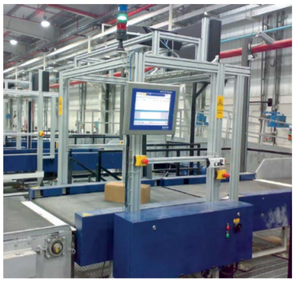

**2.2 Main Components of a DWS :**

A DWS system can be made up of any combination of dimensioning, weighing and scanning components. Components are controlled, data is merged by software and accessories compliment the system

**Dimensioner**

Dimensioners are either static or dynamic. Static dimensioners measure stationary objects and dynamic dimensioners measure moving items, usually on a conveyor. There are different options available depending on object shape, conveyor speed and width and spacing of parcels.

**Scale**

Different dynamic-scale options depend on required accuracy, throughput and speed.

**Barcode Readers (Scanning)**

As part of the DWS Hand-held barcode readers can be used for manual verification.Hand-held bluetooth scanner is used for with 1 meter scanning range.

**Data-Management Software**

Data-capture software stores data from different components, merges it and sends it to the host.Basicaly the data will be send each box scanned.and data varification and validation is done at the UI level.

**Accessories**

A DWS system can be complimented with cameras, sensors, traffic lights, data displays for streamlined processes and clear data display.

**Example Dynamic DWS Configuration:**

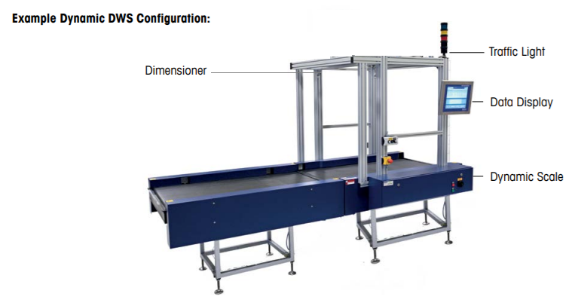

**2.3 What Does a DWS Provide :**

A DWS system provides weight and length, width and height of an object. It compares weight and dimensions in order for the dimensional weight to be determined. Identification data is captured in order to apply a data profile to each item processed.

**Typical Uses of a DWS Automation of the measuring process**

• Verification of customer-declared weight and size data

• Check data against profile in customer database

• Compliance with Weights and Measures regulations

**2.4 What kind of Items do DWS systems typically handle?**

A DWS system can be used to identify, weigh and dimension almost any item. Any configuration can be built up such as dimensioning and identification, identification and weighing, or with all three data capture elements: dimensioning, weighing and identification.

**3.Chapter 2 :**

**3.1. Automation in DWS using IT Software :**

IT Automation handshake is the best part of the Dynamic DWS sytem to make user friendly system.IT software will provide user interface to access or checked various operation of the system. This S/W will remotely accessible in network.DWS application include four component in software part.

1.User Interface(Web application)

2.Weighing and VMS Integration

3.Camera Integration Software

4.Data Management Software

**3.1.1 User Interface(Web application)**

This module is design for better visibility of the data which captured through the system.Operator/user can see the data and different report using this web application.following screens are provided in Web Application.

1. ✓ Login .
2. ✓ Dashboard.
3. ✓ Reports.
4. ✓ User Management.
5. ✓ Calibration box settings.
6. ✓ Alarm/Fault Master.

**Set Up web application**

**Login**

Launch the application by entering the provided link in browser.

Once application is launched Login screen will open.

Enter the given credentials and login to the application.once login successful landing page will open

As shown in image below img1 and img2

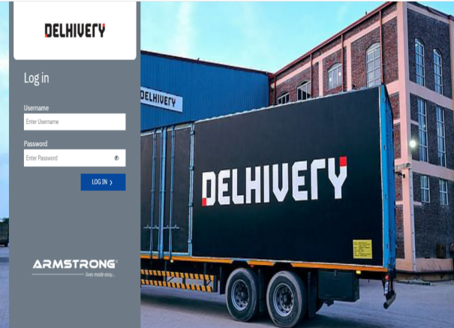 img1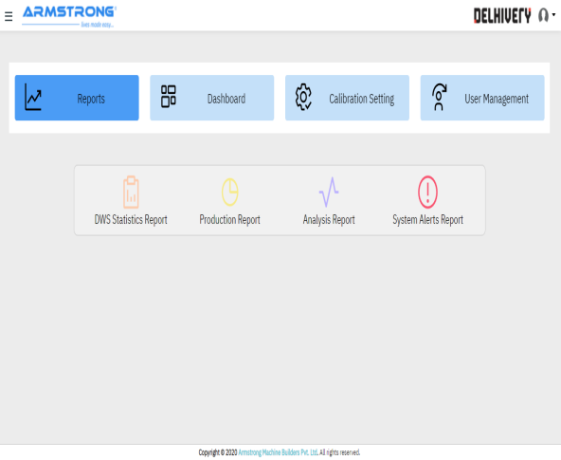img2

In the landing different menus are available.by clicking on the different menu user will redirect to the main page

**Dashboard-**

Web application contain live dashboard.this live dashboard will show the live tracking of the parcel.I.e barcode of the box,weight ,length,width,height of the scanned box.

Dashboard has functionality to download current data in excel sheet and to search data for date range.

On dashboard different alarms are shown at the bottom of the page.

Dashboard is shown in image below.

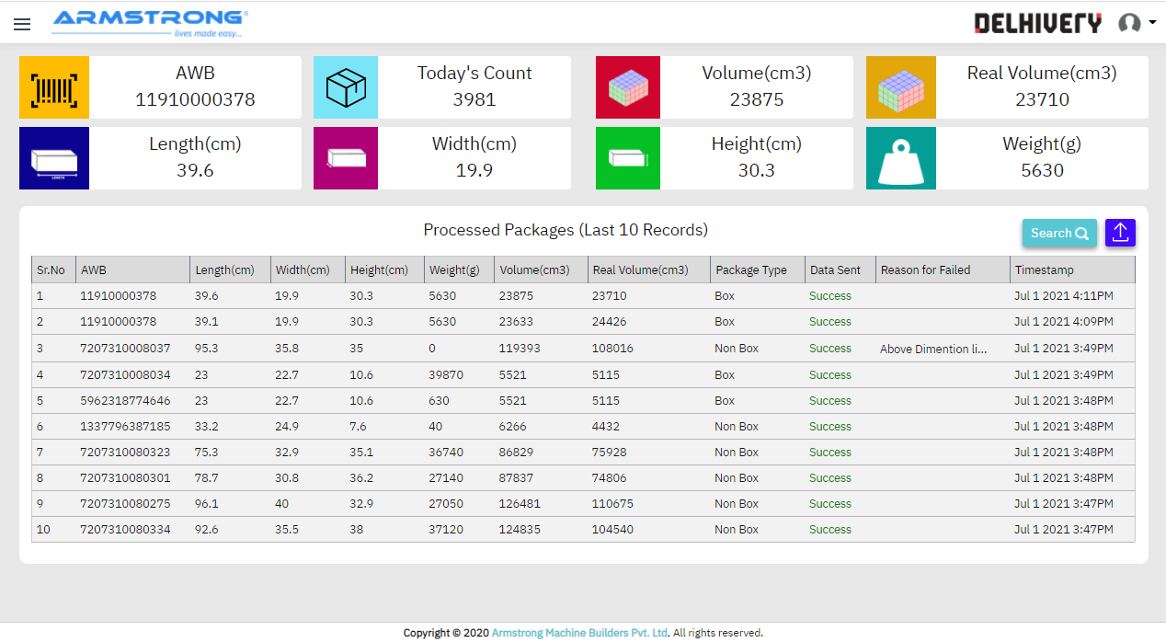

Reports-

Report module contain the tabular and graphical format report for the production analysis.

Tabular report is shown in image below.

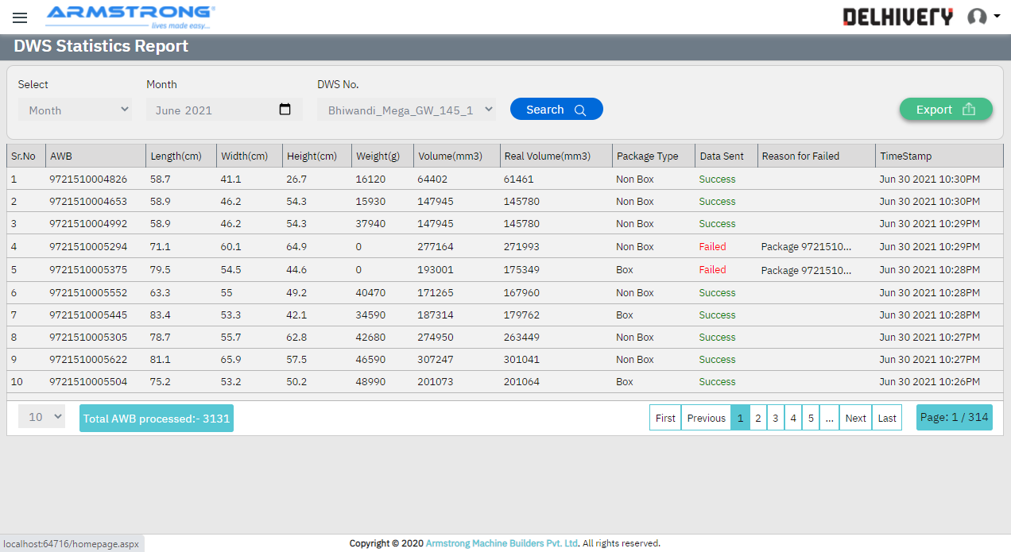

On report screen there are different parameters are available for the searching data i.e date,date range,month,week.

User can search data between different parameters.

In graphical format report are shown in image below.

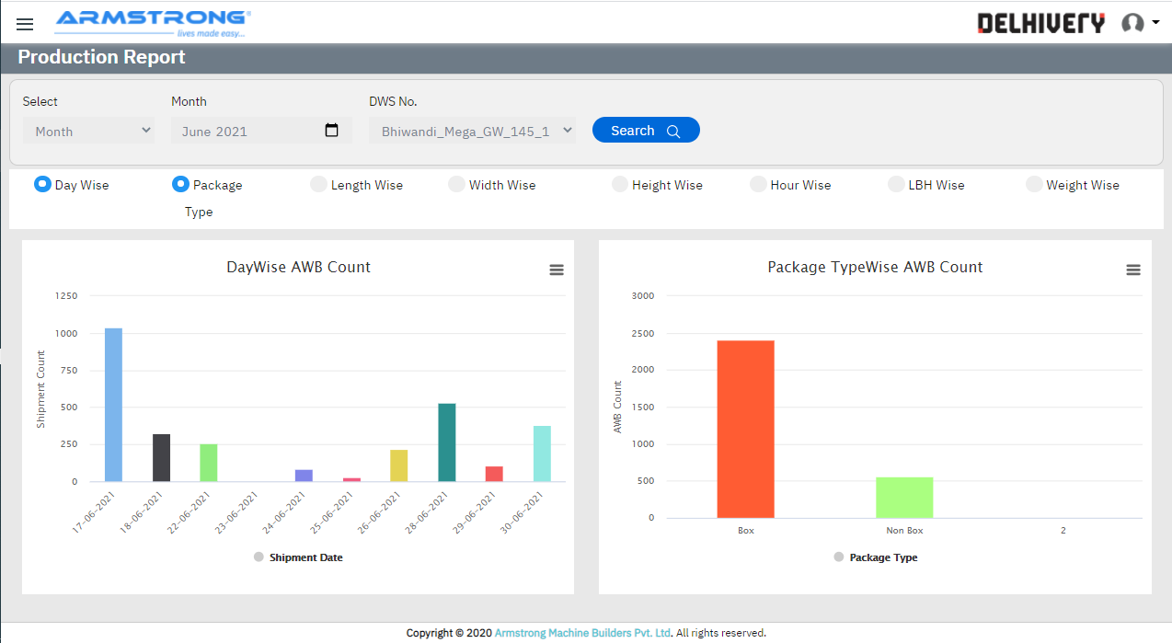

In the graphical report user has different options I.e Day wise,Package,Length wise,Width wise,Height wise,Hour Wise,LBH wise,Weight Wise.

In tabular format report there is option to download report in excel sheet.by clicking on the Export button user can download report in excel sheet.

**User Management-**

To access screen user access rights are provided user can set different access rights for the operator or any user group.

User can create user and user group.can change the user credentials.

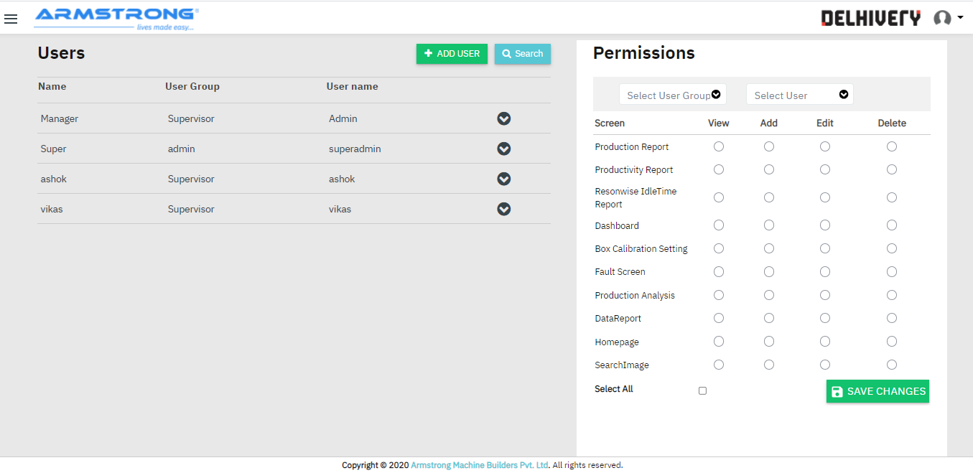

**System Alerts-**

DWS System provide different system alerts to to rectify the issues and alerts which are occurred.

System fault screen is as follows.

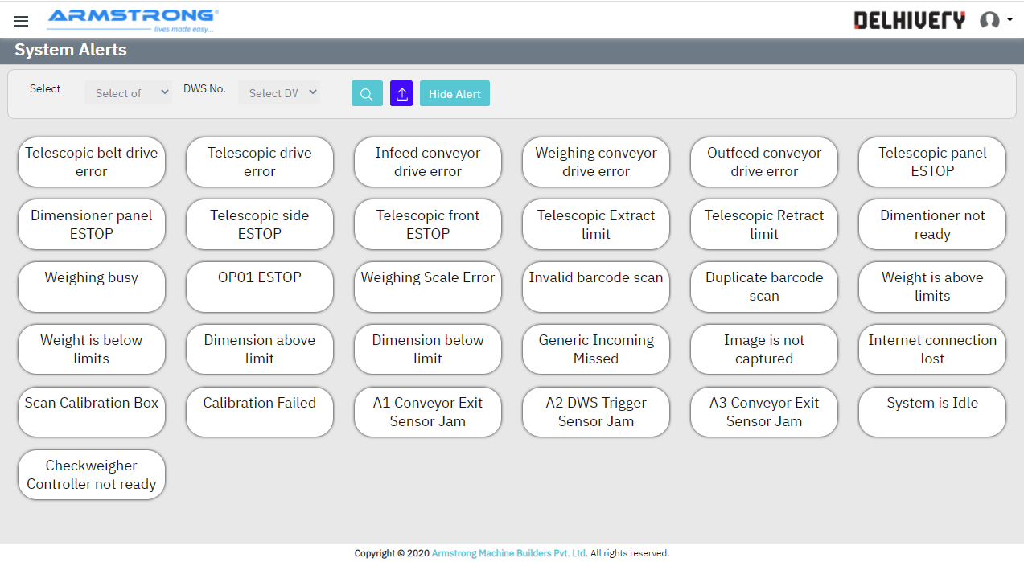

System Alerts Page Shows All Error If Any Error Active in System Then Change There Background Color white To Red shows in Below Fig.

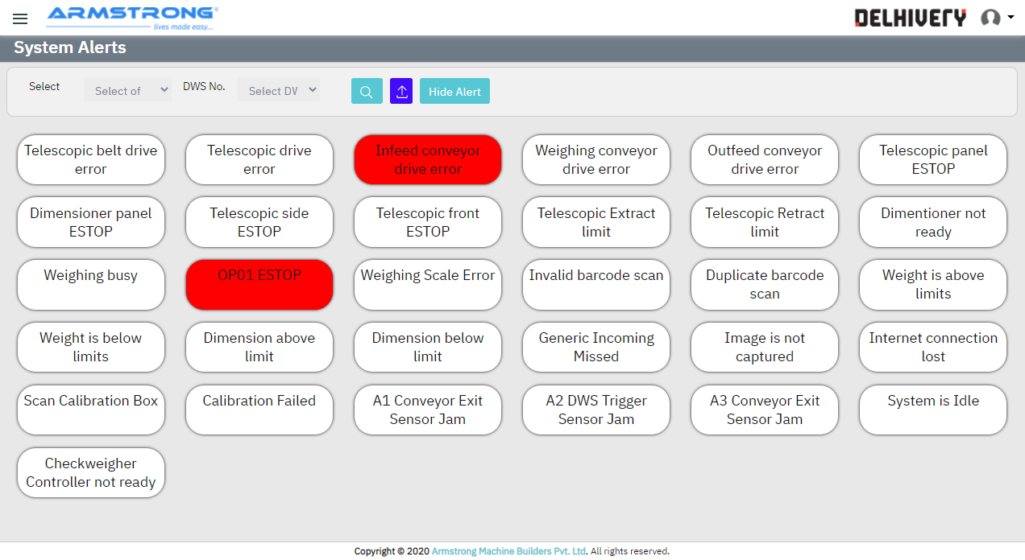

To Check System Alerts Data click on hide table

Following Screen Open

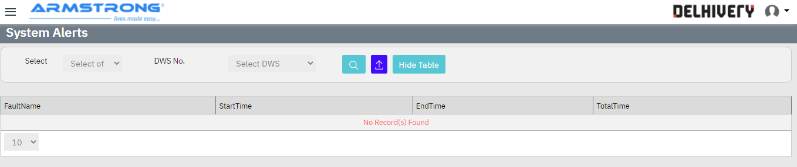

Select Type of Search(Date, Week, Month, Date Range ) And Click on Search You Will Get Data in Table Format.

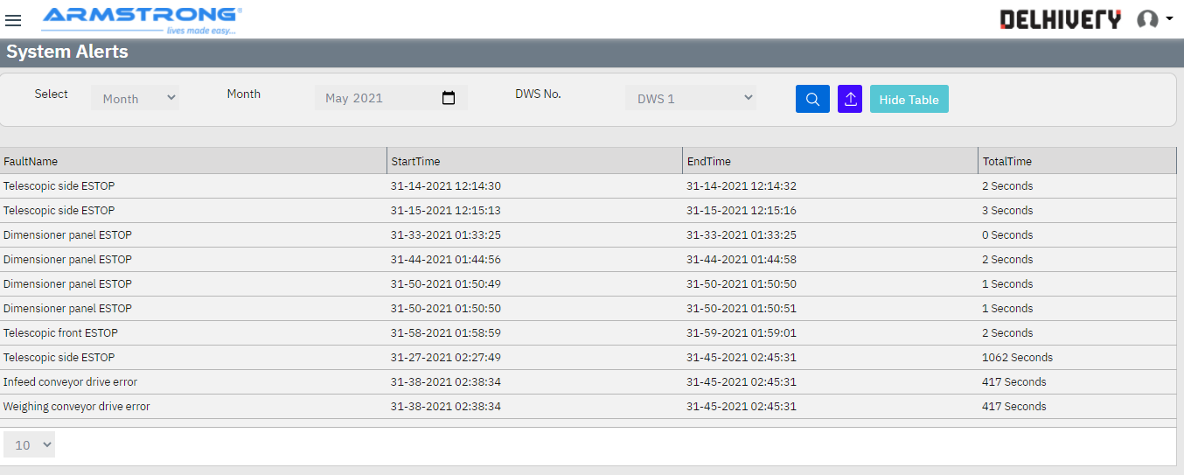

Export Alerts Data With Different parameters like monthwise,weekwise,datewise.

**Calibration Setting**

Login >> Landing Page >> Reports >> Calibration Setting

DWS system has functionality to check calibration box for QC.

Calibration Setting Shows All Details of Calibration Box And We Can Insert Calibration Box Details in Calibration Box.We Can Insert only 5 List of Calibration box. And table shows Details of Calibration Box Details. After the set duration calibration box need to test once the limit is reached Calibration box message will display on the HMI.so operator need to put calibration box and if calibration is success then other box will allow for scanning.this calibration box shows the status of the system .

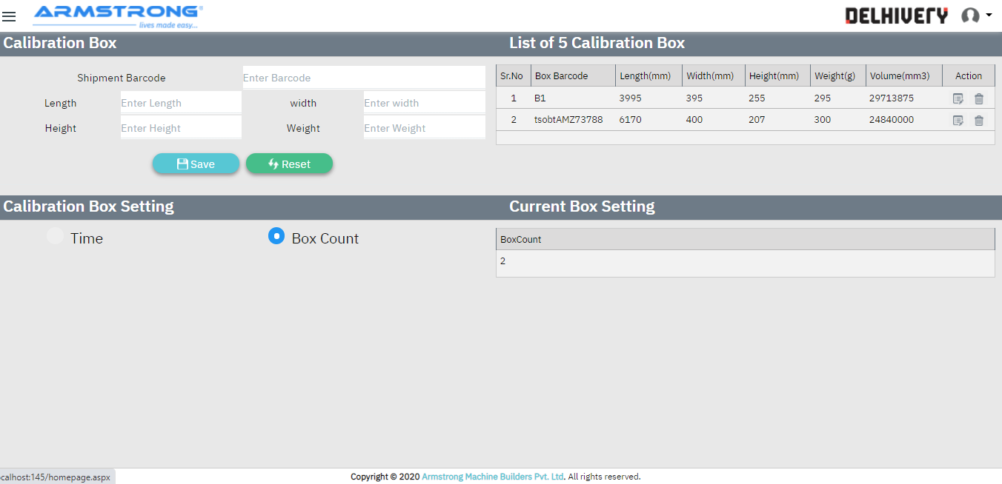

For Setting of Box Count Click on Box Count 28 One Input box Appears insert Count and click on Save

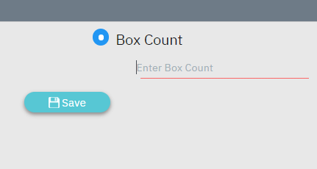

For Setting of Time For Calibration Box Click on Time Checkbox 30 one Input Box Appears insert time in Minutes

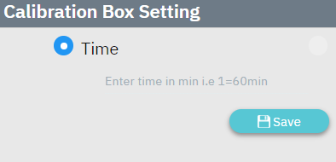

Current Setting of Calibration Box Shows in Table Following

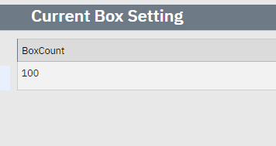

**3.1.2 Weighing and VMS Integration**

Weighing software will installed on server/Computer.Software

will captured weight and LBH data on Ethernet TCP/IP and save that information

into Armstrong database and share with the WMS server.

To start the production Operator has to start the AMBPL_Weighing application from the desktop.

**3.1.3 Camera Integration Software**

This will captured the image and save on local drive with shipment barcode.also

write Weight ,LWH information on image.Images will save on local drive upto 30

days .after 30 day images will removed from local drive.this time will be changes.

Hikvision camera is used for the image captured.this camera is mounted on the canopy before the weighing conveyor.

**3.1.4 Data Management**

Data management software is used to transfer, merge and store data from the different components of a DWS system.and share that captured data to host/customer ERP

For data handshake communication we are using following communication method.

1. Web API handshake.
2. SAP handshake
3. DB to DB handshake.

Data management and transfer method will work as follows.

